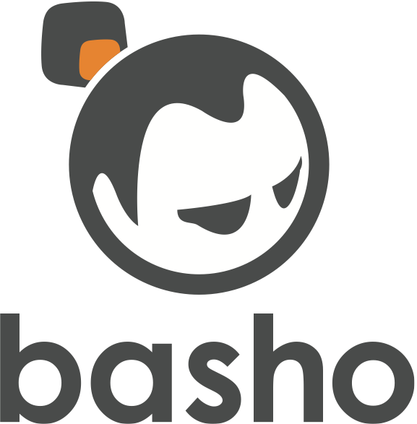

**Lab 100 - Basic Querying**

2013/10

Core Fact: Riak is ***the*** ops-friendly database.

Have students setup devrel, join the cluster, and perform basic query operations.

This module depends on two things:

1. Creating EC2 instances for trainees to use.

a. AMI ID is: ami-d7c75fe7 available only in the US-West (Oregon) zone.

b. Copy the public DNS URLs to the EtherPad at https://basho.etherpad.mozilla.org/1

password: laboratory

2. Having them assign themselves to an EC2 instance

a. have them visit <http://riak.co/basic-lab>

b. put their names next to a URL

c. visit that URL in a browser

The AMI allows access to both a webshell on standard port 80 and over SSH on port 22.

SSH u: riak, p: basho

Haproxy is installed and listening on 443 (not actually SSL, just as a way to prevent possibly being blocked by conference network). The backend is configured to forward to devrel ports, so any devrel cluster that gets setup will be automatically available externally over port 443.